Sightseeing and Excursions
Tbilisi Walking Tours

Tbilisi Walking Tours are really interesting to be experienced, when mounting Mtatsminda or Narikala it feels like flying over the city. You should go through this adventure to feel what really life is and what the city offers. Explore the city by overlooking from the height. More about Tbilisi walking tours: http://www.tbilisi.gov.ge/index.php?lang_id=ENG&sec_id=3867

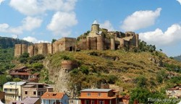

Narikala walking tour enables you to explore the
city by overlooking from the height

Read more...

http://www.tbilisi.gov.ge/index.php?lang_id=ENG&sec_id=4420

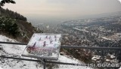
Mtatsminda
Wonna feel fit and interesting ? Visit Mtatsminda
and feel what the real thrill is

Read more...

http://www.tbilisi.gov.ge/index.php?lang_id=ENG&sec_id=4421

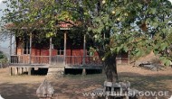
Ethnographical Museum
Save your precious time and money, don't miss to
visit ethnographical museum to see the whole
Georgia all at once

Read more...

http://www.tbilisi.gov.ge/index.php?lang_id=ENG&sec_id=3949

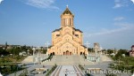
Churches doing a great part in the city life and in
spiritual breeding of the generations

For more info visit:

http://www.tbilisi.gov.ge/index.php?lang_id=ENG&sec_id=3874

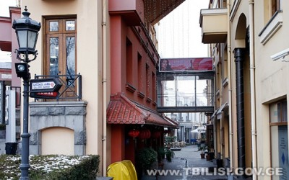
If you visit Tbilisi we recommend to visit Sharden as it is the
heart of the city's cultural and entertainment events. Sharden is
one of the most fashionable points of Tbilisi. Various sorts of
events often take place here. It is the spot where the fancy
restaurants, café-bars are located. This spot features the best
galleries and souvenir shops, where something interesting is
always found for everybody and especially for the visitors.
Fashion shows are not rare occasions in this spot.
http://www.tbilisi.gov.ge/index.php?lang_id=ENG&sec_id=3873

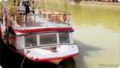
Night Office Boat Tour

Follow the flow of the river and enjoy the unusually beautiful
city views, have fun with your pals

Read more...
http://www.tbilisi.gov.ge/index.php?lang_id=ENG&sec_id=4424


Bus Tours

All city attractions will open up before you if you decide to
explore the city by bus

Read more...
http://www.tbilisi.gov.ge/index.php?lang_id=ENG&sec_id=4423

